2019 Summer Internship Guidebook

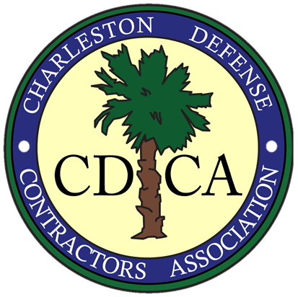
Charleston Defense Contractors Association (CDCA)

Table of Contents

Introduction Page 3

Sponsor Company Internship Requirements Page 3

Intern Requirements Page 4

Program Timeline Page 4

Event Locations Page 4

CDCA Committee Contacts Page 5

Introduction
The Charleston Defense Contractors Association (CDCA) Summer Internship Program was established to connect qualified college student candidates in the Defense industry within the Charleston metro area. The program builds upon the precipice to enhance and support workforce development for the Defense Industry as part of the charter for the Education and Workforce Development Committee. The CDCA will provide a stipend to Member companies to supplement the cost of labor for these interns. We encourage companies to increase the hourly rate to attract higher caliber interns. Host companies must be corporate members in good standing of the CDCA.
The program is designed to mutually benefit both the interns and sponsoring companies. Businesses are able to develop a pipeline of experienced and known candidates—potential assets to their organizations. Interns are provided the opportunity to gain understanding of practical applications in real-world situations, with guidance and mentoring.
This program incorporates leadership, experience, and networking opportunities for college students with Science, Technology, Engineering, and Mathematics (STEM) career paths. Interns will have an opportunity to gain valuable experience in the Defense Industry and learn important leadership and communications skills. The interns will also have the ability to attend networking functions and training that will require them to engage with other business professionals. Candidates must have an exceptional resume, relevant experience, list of extracurricular activities, and letter of recommendation from the sponsoring company.
Sponsor Company Internship Requirements
Sponsor companies must be Platinum or Corporate members of the CDCA and in good standing.
- Selection Process
  - Letter of Intent (LOI) must be completed by companies on time and can be found on the CDCA website under the Education tab.
  - Sponsor Companies advertise respective positions.
  - Must be a Corporate or Platinum level member with CDCA.
  - Sponsor Companies select one qualified candidate and complete a CDCA Internship Program application for consideration; all complete internship application packages must be submitted via either email to intern@charlestondca.org or mailed to the CDCA Education and Workforce Development Committee, PO Box 61089, North Charleston, SC 29419. Incomplete applications or late submissions may not be considered.
  - Company W-9 should be submitted with the application for tax purposes.
- Preferences In Selection
  - Preference will be given to qualified applicants on a first-come, first-serve basis
  - Preference will be given to new applicants to ensure fairness of opportunity to all CDCA Members
- Requirements for Interns
  - Must be a resident of South Carolina (waiver appeals may be considered)
  - Must be a college student pursuing a degree at a South Carolina College or University (waiver appeals may be considered)
  - Must be a Citizen of the United States of America
- Event Attendance
  - Sponsor companies are required to attend the following scheduled events with intern:
    - Summer Internship Kickoff Social Event
    - End-of-Summer Internship Program Appreciation Luncheon
Intern Requirements
- Selection Process
  - Intern applicants must:
    - Be in good academic standing
    - Provide a GPA/transcript with relevant experience as part of demonstrating relevant qualifications for the Defense Industry
- Event Attendance
  - Interns must attend the following scheduled events with their sponsor company:
    - Summer Internship Kickoff Social Event
    - End-of-Summer Internship Program Appreciation Luncheon
- Presentation Describing Internship Experience – To be Written by the Intern and Company
  - The presentation should reflect the activities performed and lessons learned during the internship
  - The presentation is due in order to complete the internship program. The presentation should be a collaboration between the company describing the impact of the internship to the company as well as the intern’s perspective on experience gained during the program.
2019 Program Timeline
- February 28, 2019 – Internship Program Open: Member companies begin sending full job descriptions and point-of-contact information to the CDCA via Letters of Intent (LOI)
- March 8, 2019 – Deadline for Company LOI and CDCA provides final update to schools regarding availability of internship opportunities

- March 22, 2019 – Deadline for company to submit completed application and company W-9
- April 2, 2019 – CDCA 2019 Internship Winners Announced
- June 4, 2019 – Summer Intern Kick-Off Social

- July 30, 2019 – End-of-Summer Internship Program Appreciation Luncheon and Internship Program Presentation deadline
Event Locations
Summer Internship Program Kick-Off Social
June 4, 2019 | 11:30am – 2pm
Location: Goodwill Industries, Eagle Drive, North Charleston, SC. 29406.

Intern Appreciation Luncheon
July 30, 2019 | 11:30am – 2pm
Location: Goodwill Industries, Eagle Drive, North Charleston, SC. 29406.

CDCA Summer Internship Program Contacts
Sub-Committee: intern@charlestondca.org

Stella Mercado
Chair, Education and Workforce Development Committee
Phone – 703-629-5986
Email – mailto:smercado@charlestondca.org

Kris Busch
Co-Chair, Education and Workforce Development Committee
Phone – 843-614-5944
Email – mailto:kbusch@charlestondca.org

